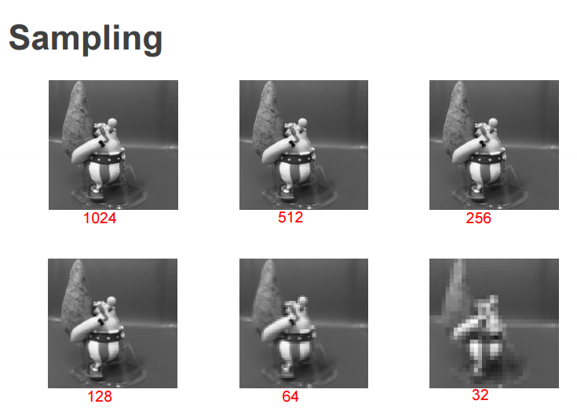Lecture 4 – Image Processing for Physiological Measurement

Image vs. Digital Image

* Image
  + 2D function f(x,y) with x and y, being the spatial (plane) coordinates
  + Amplitude value of (f) from any pair of co-ordinates (x,y) is the intensity of the image
* Digital Image
  + If x, y and amplitude of (f) are finite and discrete quantities, called digital image
  + Made up of pixels, each with specific location and value
    - 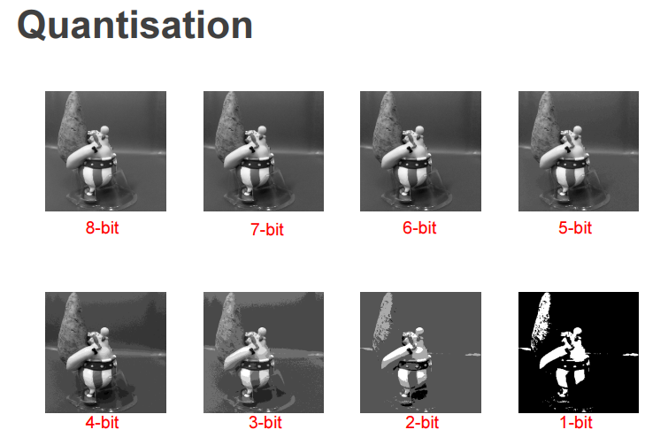Different colour intensity for each point
    - Stored as 8-bit binary number (0 – 225)
    - Color Digital Image
      * 3 channels
      * RGB colour intensities
    - Grayscale Digital Image
      * 1 channel
      * Grey intensity (range black $→$ white)
  + Spatially: Sampling rate determines spatial resolution
    - As reduced, becomes pixelated/blurry
  + Amplitude: Quantization level determines no. of grey levels
    - 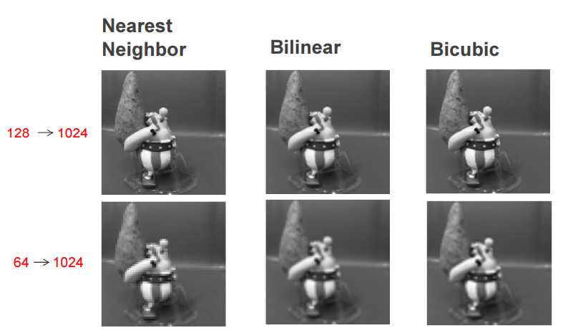As bit decreases, grey areas blend into light areas $→$ turns black

Interpolation Methods

* Nearest neighbor interpolation
  + Estimating nearby intensity values for pixels
  + Uses nearby pixels for the output of pixel values
* Bilinear interpolation
  + Interpolation in one direction, and to the next
  + Weighted average of two pixels for output pixel value
* Bicubic interpolation
  + Favorable if speed is not needed $→$ clearer pictures
  + Weighted average of four pixels for output pixel values

Filtering

* Remove noise (dirt, dots, speckles, stains) from image and enhance it
  + Average or median values of neighboring pixels
  + Low-pass filtering
    - Can blur edges
    - Advanced techniques required: adaptive, edge preserving
* Value of given pixel in output image is determined by determining values of nearby pixels from the input pixel
* Mean/Average Filter
  + Replace each pixel by average of pixels in square window surrounding input pixel
  + Smooth image by averaging out sharp transitions
  + $↑$ noise removal $→$ $↑$ blur details/edges
* Weighted Average Filter
  + Closer pixels have $↑$ weighting, while far-away pixels have $↓$ weighting, from input pixel
  + If all weights are positive, corresponds as weighted average
  + If low frequency and suppression of high frequency = low-pass filter
* Median Filter
  + Problems
    - Blur edges/details
    - Ineffective to impulse noise (irrecognisable bright and dark zones on image)
  + Takes median value of pixels in the input pixel window, ie. Takes middle one from increasing order of pixel
  + Improve by enhancing pixels, not performing as expected
* Top-hat filtering
  + Computers morphological opening of an image and subtracts result from original image

Image Sharpening

* Enhance line structures or other details in image
  + Enhanced image = original image + scales version with enhancements in image
* High – Pass Filter, or weighted averaging
  + Taking difference between current and averaging (weighted average) of nearby pixels
  + Used for edge detection

Contrast Stretching

* Improves contrast in image by stretching range of intensity values it contains
  + Upper and lower pixel value limits specified before image is normalized and stretched
    - Eg. 8-bit gray-levelled image has limits of: 0 and 255

Image Histogram

* Plots pixel no. for each pixel intensity in digital image
* Can judge entire tonal distribution
* Scanning at one moment and count of pixel no. for each intensity value is taken $→$ Histogram constructed
* Histogram equalization is distributing pixels evenly over intensity range $→$ creating a ‘flat’ histogram
* Can determine threshold value to convert grayscale image to binary one
  + Suitable for thresholding; histogram will be bi-modal $→$ clustering of pixel intensities around two-separated values
    - Suitable threshold found between two peaks in histogram
    - If not, unlikely for good image production by threshold value

Otsu Thresholding

* Computes global threshold level, used to convert intensity image to binary image
  + Threshold chosen to minimize variance between black and white pixels

Morphological Operations

* Attempt to remove imperfections by accounting for form and structure of image
  + Imperfections being noise and texture
* Creates new binary image where input pixel has a non-zero value if test is successful at specific location
* Structuring element
  + A small matrix of pixels, with a value of zero or one
  + Positioned at all possible locations of image and compared to nearby pixels
  + Processes can test whether element fits in neighborhood, while others test if it hits or intersects neighborhood
* Morphological Erosion
  + Tests whether structuring element fits in neighborhood
  + Used for separating touching objects in a binary image for counting
* Morphological Dilation
  + Tests whether structuring element hits or intersects neighborhood
* Morphological Opening
  + Morphological erosion followed by dilation with same structuring element
  + Can:
    - Separate out circles from lines
    - Separate horizontal and vertical lines apart
* Morphological Closing
  + Morphological dilation followed by erosion with same structuring element

Region Properties

* Returns measurements for set of specified properties for each connected component in binary image
* (stats) is struct array containing a struct for each object in image